MANCASS and Fred Olsen cruise to France & Northern Spain

Bolette T2730 Sails from Newcastle

9 nights 17th – 25th Oct 2027

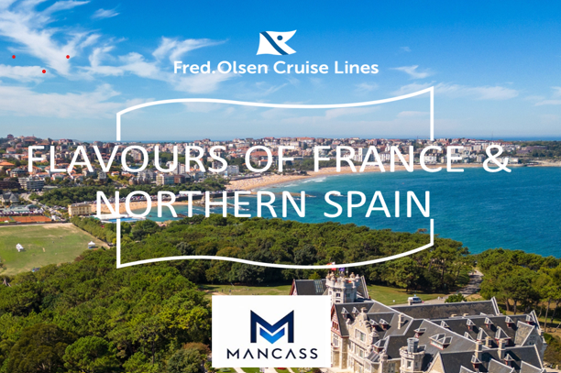

Timed for autumn’s rich food traditions, this cruise brings opportunities to sample local produce in less visited regions of France and Northern Spain. Each shaped by its own architecture and way of life, with October’s milder temperatures adding to appeal.

In Honfleur, colourful half-timbered buildings and artisan shops line the harbour, creating a picturesque setting to sample Calvados and Camembert.

Gijon brings a taste of Asturias through its renowned cider, poured in traditional sidrerias using a distinctive method.

While Pauillac places you within easy reach of Bordeaux’s celebrated vineyards.

In Santander beach strolls, pintxos and freshly caught seafood await, before a scenic departure past the Magdalena Peninsula

Transport:
Coach travel will be arranged from the North West to and from the port in Newcastle.
Details to follow.

Itinerary

Pricing
Please note the prices below are only available until the 16th of July 2026 after which they will go up.
Twin / Double Cabins:
Interior twin fare (I grade) from £899 per person.
Ocean-view twin fare (E grade) from £1,259 per person.
Superior ocean-view twin (C grade) from £1,439 per person.
Balcony suite twin fare (BJ grade) from £2,069 per person.

Solo travellers:
Interior solo fare (M grade) £1,079.
Ocean-view solo fare (K grade) £1,309.
Superior ocean-view twin cabin for sole occupancy, with restricted view (CO grade) £1,689.

Gratuities and Drinks with Lunch & Dinner included.

How to Book

Please contact the Fred Olsen bookings team direct on 0800 0355 144
Quoting the MANCASS Group Reference - GRP0332 and cruise code T2730 also requesting the 8pm dining time.
Please note a 15% non-refundable deposit is required to Fred Olsen at the time of booking.
The balance due is payable direct to Fred Olsen 90 days prior to sailing.

Queries
Any questions regarding this trip please contact CLAIRE ASPIN – clairea.1963@outlook.com.

